Stagger Calculator Guide

March 2021

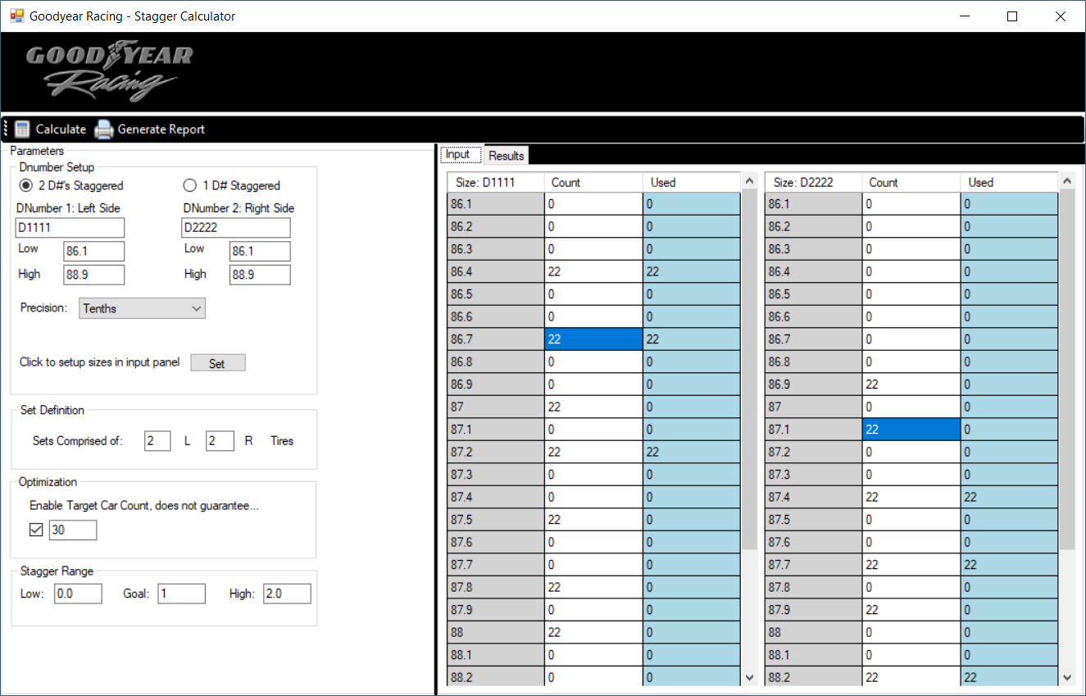

1. Setup Dnumber data
   1. Select 2 dnumber mode if you are using 2 separate codes for the event, or 1 dnumber stagger if you only have 1 dnumber for the event.
   2. Select the precision
      1. Tenths, if tires are measured in 0.1” increments (i.e. 0.1, 0.2, 0.3… )
      2. Quarters, if tires are measured in 0.25” increments (i.e 0.25, 0.50, 0.75)
   3. Select the “SET” button to lock the settings in, the grid in the “Input” panel will update to reflect
2. Set definition
   1. Input what constitutes a “Set” – by default a set is 2 left, and 2 right tires
3. Enable optimization
   1. This assists the algorithm in getting the best “Goal” stagger for a set number of cars.
4. Stagger Range
   1. The Goal value represents the target Stagger in inches
   2. Low, and high are the +/- range you are willing to allow the stagger to deviate from Goal.
5. Enter into the Count column, each dnumber/size count that is in inventory
6. Select the Calculate button at the top left to initiate distribution algorithm
   1. This will open the “Results” Tab with the resulting set counts per size
7. Select the “Generate Report” at the top, to generate the PDF report for printing.